Web Programming Language

Final Project Report

Group Name:

Ubertrix

Group Members**:**

* Jay Sharma jms140730
* Kaushal Shah kbs140130
* Vaibhav Shah vvs140130

Project Title:

UTD Free and for Sale

UTD Free and for Sale

Introduction

UTD Free and for Sale is intended to display advertisements for selling different products to students of UTD. Seller can the University itself or any student currently enrolled in UTD. It gives the users a single platform to view all the products segregated by categories.

The seller can post products for bidding by giving the base price or can sell a product at a firm price. For bidding process, the user with the highest bid will be able to buy the product. At the end of the bid, the buyer and the seller will get an email containing contact details of the other party. For products sold at firm price, the first user to click the buy button will be able to buy the product and will receive contact details of the seller.

Architecture:

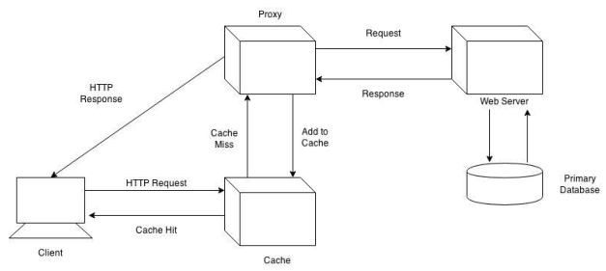

Services:

* Creating user account.
* Posting advertisement for selling products.
* Change Password.
* Search for products.

Functionalities:

* User can create account.
* Users can update their password.
* Users can list a product for selling.
* Users can search for products by category.

Technology Used

Web services considered

RESTful Web Service

RESTful web services are built to work best on the Web. Representational State Transfer (REST) is an architectural style that specifies constraints, such as the uniform interface, that if applied to a web service induce desirable properties, such as performance, scalability, and modifiability that enable services to work best on the Web. In the REST architectural style, data and functionality are considered resources and are accessed using Uniform Resource Identifiers (URIs), typically links on the Web. The resources are acted upon by using a set of simple, well-defined operations. The REST architectural style constrains an architecture to a client/server architecture and is designed to use a stateless communication protocol, typically HTTP. In the REST architecture style, clients and servers exchange representations of resources by using a standardized interface and protocol.

SOAP Web Service

Today's applications communicate using Remote Procedure Calls (RPC) between objects like DCOM and CORBA, but HTTP was not designed for this. RPC represents a compatibility and security problem; firewalls and proxy servers will normally block this kind of traffic.

A better way to communicate between applications is over HTTP, because HTTP is supported by all Internet browsers and servers. SOAP was created to accomplish this.

SOAP provides a way to communicate between applications running on different operating systems, with different technologies and programming languages.

Advantages of RESTful over SOAP

* REST is more dynamic, no need for creating and updating UDDI.
* REST is not restricted to XML format. REST web services can send plain text, JSON, and also XML.

Hence, we went forward with the use of REST in our project.

JSON

The JSON format is syntactically identical to the code for creating JavaScript objects.

Because of this similarity, instead of using a parser (like XML does), a JavaScript program can use standard JavaScript functions to convert JSON data into native JavaScript objects.

* Both JSON and XML is "self describing" (human readable)
* Both JSON and XML is hierarchichal (values within values)
* Both JSON and XML can be parsed and used by lots of programming languages
* Both JSON and XML can be fetched with an XMLHttpRequest
* JSON doesn't use end tag
* JSON is shorter
* JSON is quicker to read and write
* JSON can use arrays

 XML has to be parsed with an XML parser, JSON can be parsed by a standard JavaScript function.

Thus, due to many advantages of JSON we have implemented it in our project.

AJAX

AJAX = Asynchronous JavaScript and XML.

AJAX is a technique for creating fast and dynamic web pages.

AJAX allows web pages to be updated asynchronously by exchanging small amounts of data with the server behind the scenes. This means that it is possible to update parts of a web page, without reloading the whole page.

We had many instances where data is to be changed without page load, hence AJAX came to a great help.

C#

C# is an elegant and type-safe object-oriented language that enables developers to build a variety of secure and robust applications that run on the .NET Framework. You can use C# to create Windows client applications, XML Web services, distributed components, client-server applications, database applications, and much, much more. Visual C# provides an advanced code editor, convenient user interface designers, integrated debugger, and many other tools to make it easier to develop applications based on the C# language and the .NET Framework.

Services

The API that we provided

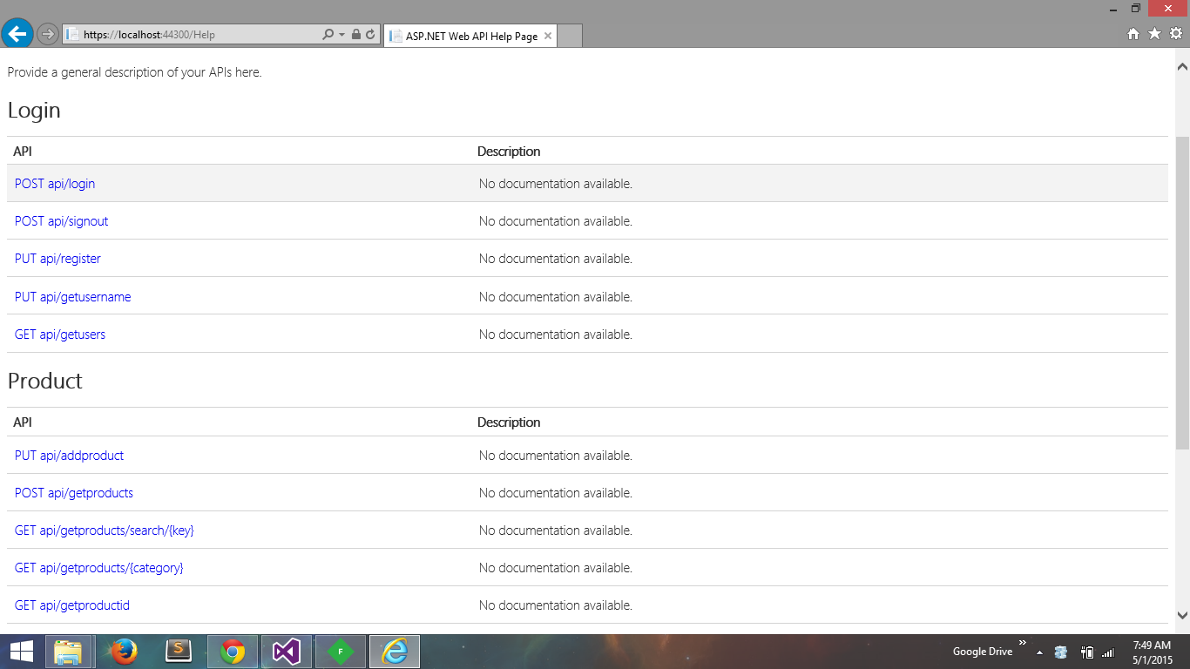

Creating user account.

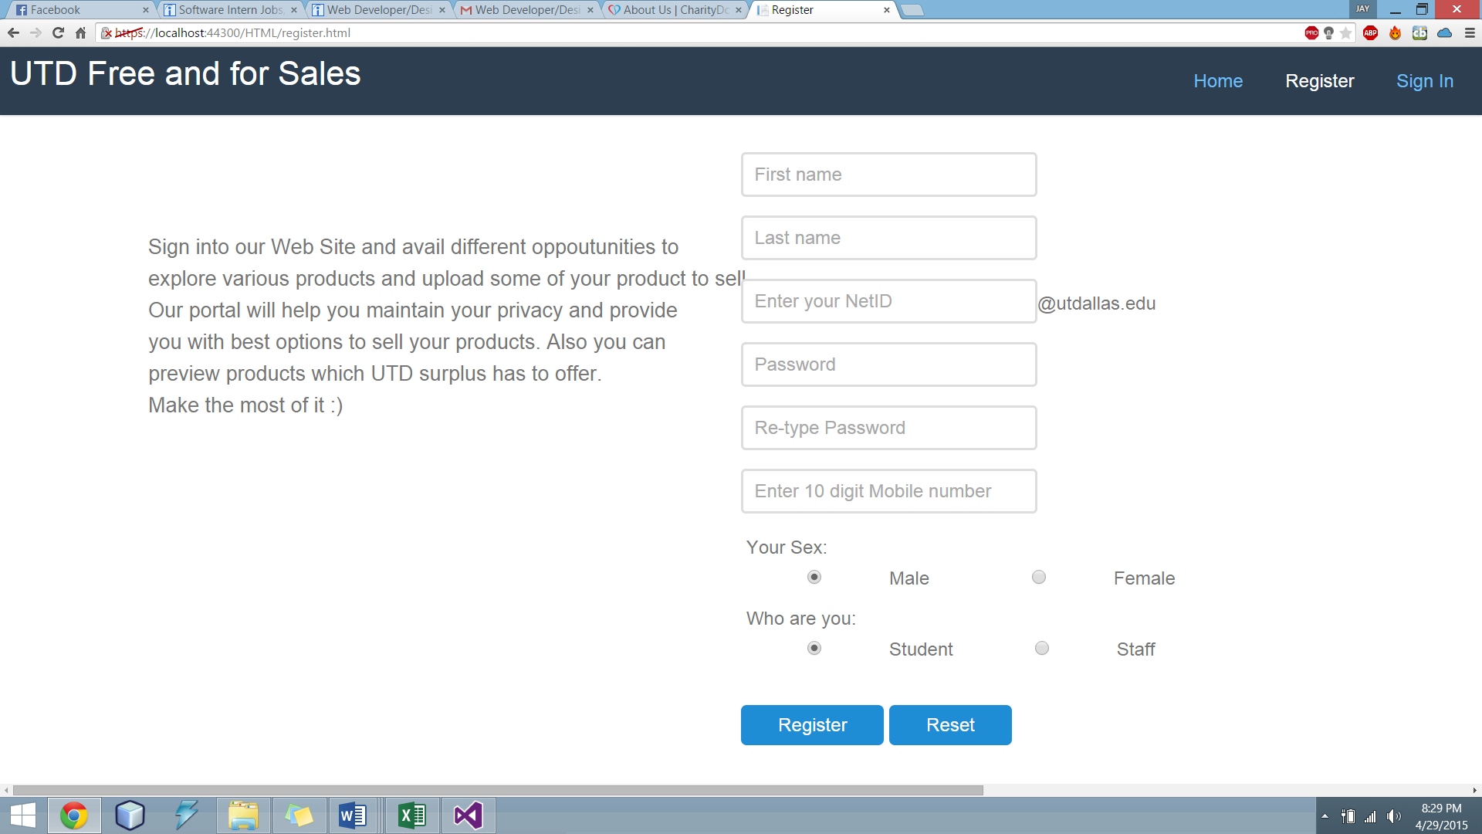

With the register page a user can create their account. The client side validations are accomplished by JQuery and CSS elements.

AJAX will send JSON data object using RESTful web service to server side class which will use the entity framework to return the requested response from the SQL database.

The user account information will be updated in the SQL database.

Search for products

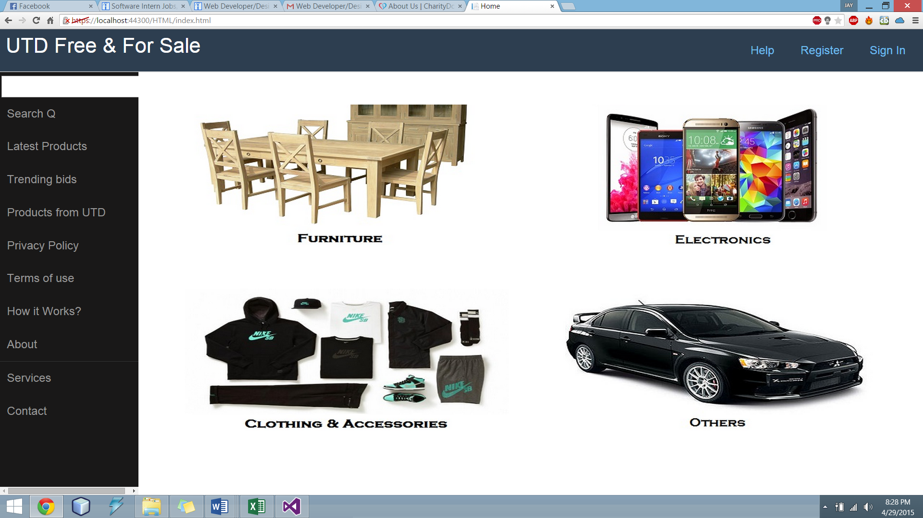

This is the homepage where user is directed to when they search this website with the domain name. As you can see, either a user can search the product by keywords of product name and description in the text box on the top of side-bar on the left or directly by clicking on the images of category of products.

The Nav bar on the top helps in navigation from Register page to Login page.

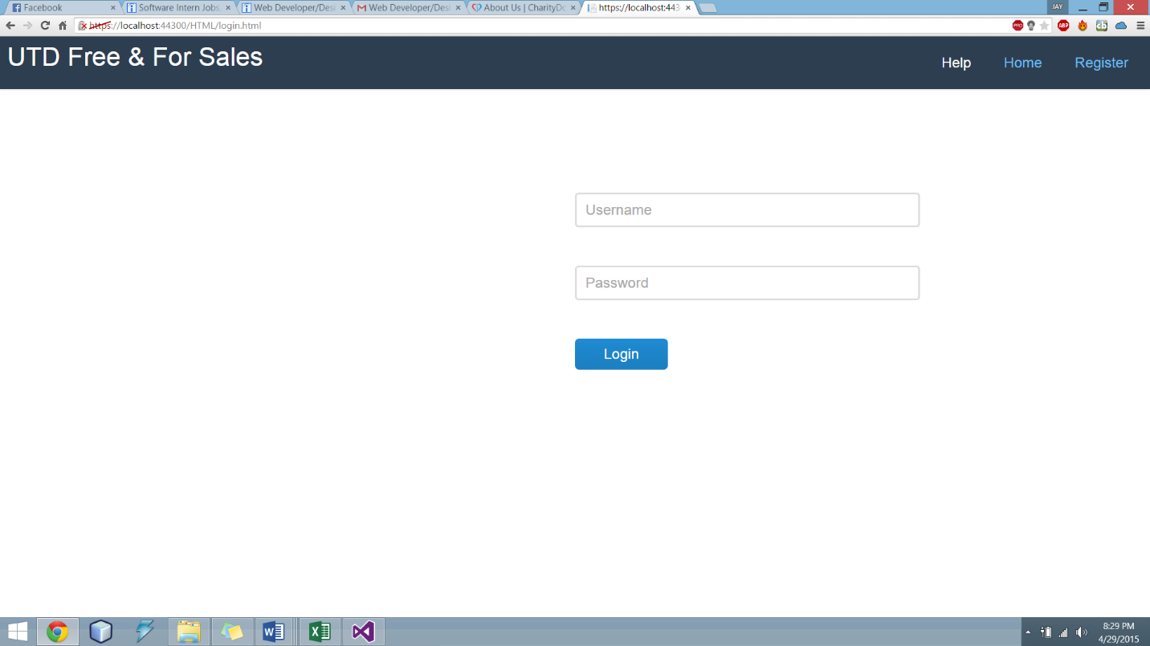Some links on the side-bar helps user understand the purpose of this website and how to make most of it.

The user can go ahead and Login themselves in, which redirects them to a Login page where username and password credentials are asked.

The user credentials will be sent in JSON data object format to the server side controller, this in turn will use Entity framework which checks if this user credentials are present in database and according to that it will send response back to client. If registered he will be directed to Home page.

Posting advertisement for selling products

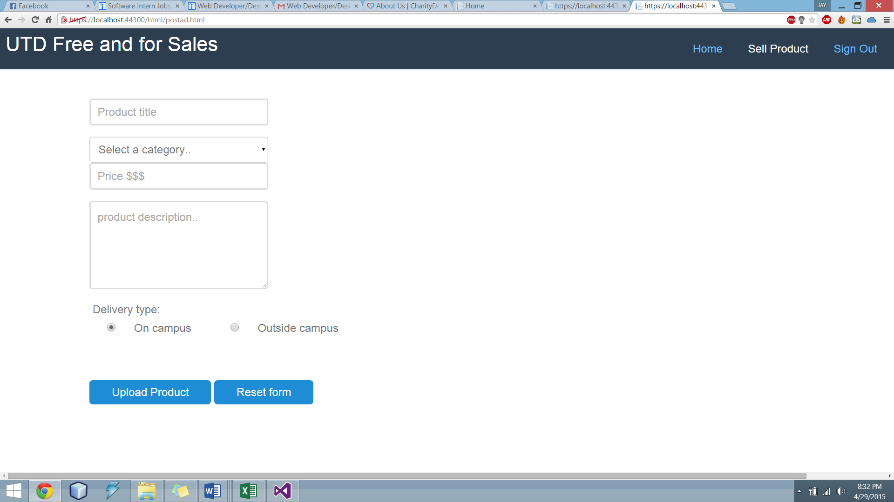

Information about the product is uploaded here which in turn is again sent by REST to server controller in JSON object by AJAX. Server controller will use Entity framework to save this information in product database.

Problems faced and their solution

1. Image upload and display problem:

The issue with the upload image was regarding the type of data object used to store the image and send it to the database for storage.

Solution:

The BLOB data type of image was used where the image is converted to byte array and this data is stored in the database. This byte array is used in the display function where image is converted from byte array to image format as specified.

1. MySQL support issue:

Initially we planned to use the MySQL with asp.net but there were limited functionalities associated with this.

Solution:

We installed Microsoft SQL server 2012 for this purpose. Since these products are from the same manufacturer and it facilitates connecting and using database in Visual Studio in easier way.